Machine Tools and Machining Laboratory
Under Graduate Laboratory
Indian Institute of Technology Kharagpur

Title: Estimation and Measurement of Machining Time in Facing in a CNC Turning Centre using constant spindle speed and constant cutting velocity

Objectives:

- To estimate the machining time in facing of a disc in a CNC turning centre using constant spindle speed
- To estimate the machining time in facing of a disc in a CNC turning centre using constant cutting velocity
- To measure machining time in facing of a disc in a CNC turning centre using constant spindle speed
- To measure machining time in facing of a disc in a CNC turning centre using constant cutting velocity
- To determine the increase in productivity by employing constant cutting velocity over constant spindle speed.

Theory:

In a centre lathe during a machining operation, the spindle speed cannot be changed. Thus during facing, as the cutting tool gradually moves from the periphery of the workpiece towards the centre, the cutting velocity reduces. But in a CNC turning centre the spindle speed can be corrected online to maintain the same cutting velocity even in case of a facing operation.
S
cutting tool

If the spindle speed (n) is constant, then the machining time (t_{m}) can be estimated neglecting the approach and over-travel as:

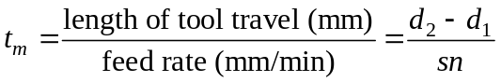

If the spindle speed is automatically compensated by the CNC system and the cutting velocity is kept constant, then the machining time (t’_{m}) can be estimated as:

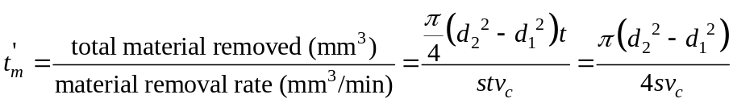

The machining time (t’_{m}) can also be calculated as:

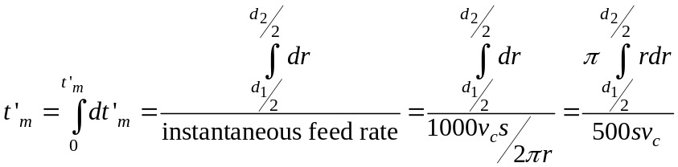

Experimental Conditions:
Outer diameter of the workpiece (d₂): mm
Inner diameter of the workpiece (d₁): mm
Work material:
Tool material:
Tool geometry:
Depth of cut (t): 0.5 mm
Cutting velocity (v_{c}): 100 m/min

# | spindle speed  n  rpm | feed  S  mm/rev | estimated time  t’_{m}  (min) | measured time  t_{m}  (min)
1a
2a
3a
1b
2b
3b

a → machining to be undertaken in constant spindle speed mode
b → machining to be undertaken in constant cutting velocity mode

Report:

- derive all the expression of machining time
- estimate the machining time for different combinations of process parameters and tabulate them
- estimate increase in productivity while employing constant cutting velocity over constant spindle speed
- derive the expression for machining time employing constant cutting velocity for taper turning

